Course Name | ITD 2313 – Script Programming
Instructor | Rene Hurst
Student Name | Pete Fuentez
Due date | Oct 20 by 11:59 pm
Grade | Put grade earned here
Grading Comments | Put instructor comments here

Week 7 - Scripting Projects Assignment
Project # 1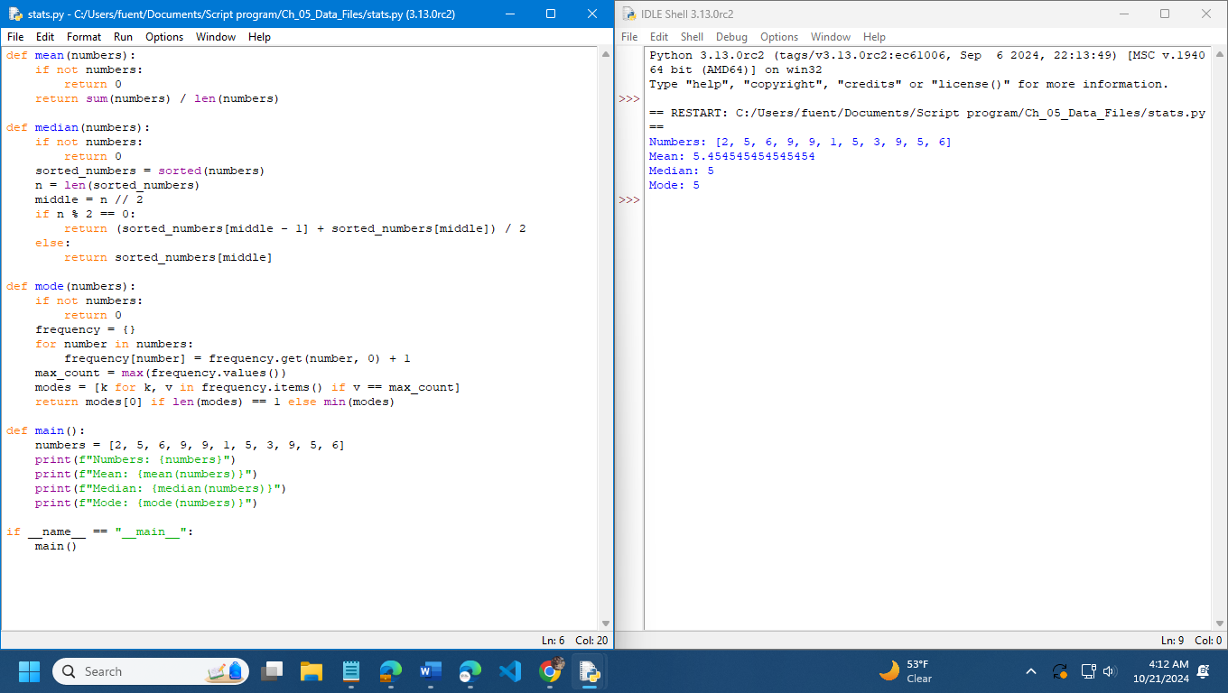

Project # 2